**SOCIAL MEDIA UPDATES**

* Website link- <http://www.scpt.co.in/>
* Gmail - [info@scpt.co.in](mailto:info@scpt.co.in)
* Twitter Link- <https://twitter.com/scop_2017>
* Facebook link- <https://www.facebook.com/SenghundharCollegeofPharmacy>
* Instagram link- <https://www.instagram.com/senghundharcollegeofpharmacy/>
* Linkedin link- <https://www.linkedin.com/in/senghundhar-college-of-pharmacy-357317273/>
* Youtube link- <https://www.youtube.com/@SCOP_2017>

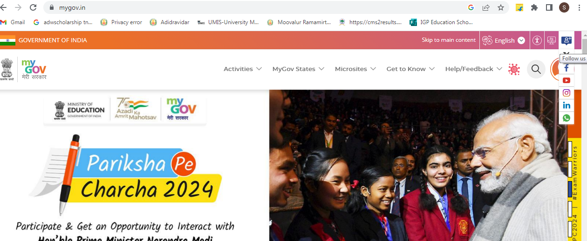

**All social media links upload like this**

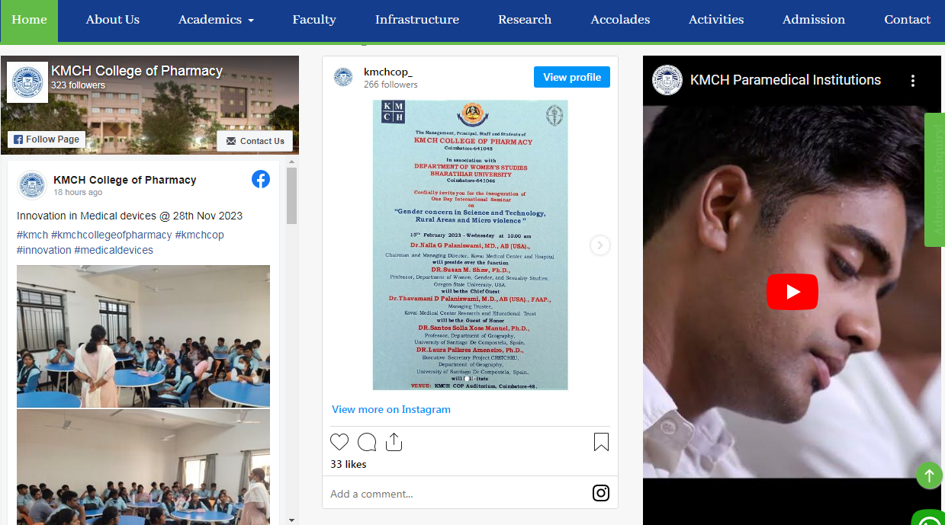

**LIKE ABOVE SOCIAL MEDIA UPDATES AUTO UPLOAD IN COLLEGE WEBSITE. ANY UPDATES POSTED ON OUR SOCIAL MEDIA ACCOUNTS WILL BE AUTOMATICALLY UPLOADED TO THE COLLEGE WEBSITE. MOREOVER, WHEN A NEW POST IS ADDED ON SOCIAL MEDIA, IT WILL EFFORTLESSLY REFLECT ON THE COLLEGE WEBSITE WITHOUT ANY MANUAL INTERVENTION**